HOSTEL MANAGEMENT SYSTEM USING FLUTTER

**AI19511 – MOBILE APPLICATION DEVELOPMENT**

**LABORATORY FOR ML AND DL APPLICATIONS**

**A PROJECT REPORT**

**Submitted by**

# ARUN KUMAR M (221501013)

**DEEPENDRA S (221501025)**

**in partial fulfillment for the award of the degree**

**of**

# BACHELOR OF TECHNOLOGY

**in**

**ARTIFICIAL INTELLIGENCE AND MACHINE LEARNING**



**RAJALAKSHMI ENGINEERING COLLEGE, KANCHIPURAM ANNA UNIVERSITY : CHENNAI 600 025**

**DECEMBER 2024**



**BONAFIDE CERTIFICATE**

### NAME ……………………………………………………………………………….…….………

**ACADEMIC YEAR…………….………SEMESTER………….BRANCH………………**

#### UNIVERSITY REGISTER No.

Certified that this is the bonafide record of work done by the above students in the Mini Project titled **" HOSTEL MANAGEMENT SYSTEM USING FLUTTER** **"** in the subject **AI19511 – MOBILE APPLICATION DEVELOPMENT LABORATORY FOR ML AND DL APPLICATIONS** during the year **2024 - 2025.**

#### Signature of Faculty – in – Charge

Submitted for the Practical Examination held on

**INTERNAL EXAMINER EXTERNAL EXAMINER**

# ABSTRACT

The Hostel Management App is designed to streamline the management of hostel facilities, providing an all-in-one platform for students, staff, and administrators. Utilizing a robust backend and a user-friendly interface, the app enables functionalities such as room allocation, fee management, maintenance tracking, and student attendance monitoring. The system is powered by a modular architecture, incorporating advanced technologies like Firebase for backend services, React Native for cross-platform compatibility, and AI-driven analytics for improved decision-making. This app addresses the inefficiencies in traditional hostel management, offering a scalable, secure, and cost-effective solution.To enhance operational efficiency further, the app incorporates AI-driven analytics for predictive maintenance and occupancy forecasting. These insights empower administrators to make informed decisions, optimize resource utilization, and anticipate future needs. By providing real-time access to data and reducing reliance on manual processes, the app not only improves accuracy and transparency but also significantly reduces administrative burden.

The Hostel Management App is a scalable, secure, and user-friendly solution, well-suited for institutions of all sizes. With its focus on digital transformation, it paves the way for a streamlined and technology-driven approach to hostel management, ensuring a better experience for both administrators and residents. This project demonstrates the potential of modern mobile application development in solving real-world problems efficiently and effectively.

The app's features include automated room allocation based on student preferences and availability, digital fee management with integrated payment gateways, and a QR code-based attendance tracking system. Additionally, the app facilitates maintenance reporting by allowing users to log issues, which are then assigned to the appropriate staff for resolution.

# ACKNOWLEDGEMENT

Initially I thank the Almighty for being with us through every walk of my life and

showering his blessings through the endeavor to put forth this report.

My sincere thanks to our Chairman **Mr. S. MEGANATHAN, M.E., F.I.E.,** and our Chairperson **Dr. (Mrs.)THANGAMMEGANATHAN,M.E.,Ph.D.,** for providing me with the requisite infrastructure and sincere endeavoring educating me in their premier institution.

My sincere thanks to **Dr. S.N. MURUGESAN, M.E., Ph.D.,** our beloved Principal for his kind support and facilities provided to complete our work in time.

I express my sincere thanks to **Dr. K.SEKAR, M.E., Ph.D.,** Head of the Department of Artificial Intelligence and Machine Learning and Artificial Intelligence and Data Science for his guidance and encouragement throughout the project work. I convey my sincere and deepest gratitude to our internal guide, **Dr. PAVITHRA GURU Ph.D.,** Associate Professor, Department of Artificial Intelligence and Machine Learning, Rajalakshmi Engineering College for his valuable guidance throughout the course of the project.

Finally I express my gratitude to my parents and classmates for their moral support and valuable suggestions during the course of the project.

# TABLE OF CONTENTS

**CHAPTER NO TITLE PAGE NO**

**ABSTRACT**

**ACKNOWLEDGEMENT**

III IV

### LIST OF TABLES 1

### LIST OF FIGURES 2

### LIST OF SYMBOLS 3

### INTRODUCTION 4

### LITERATURE SURVEY 9

### PROPOSED METHOD 11

* 1. DATA
  2. FRONT END
  3. BACK END
  4. DATABASE
  5. APPLICATION
  6. DEPLOYMENT

1. RESUTLS AND DISCUSSION 17

REFERENCES 30

OUTCOME 33

|  |  |  |
| --- | --- | --- |
|  | **LIST OF FIGURES** |  |
| **FIG.NO** | **TITLE OF THE FIGURE** | **PAGE NO** |
| 3.1 | Overall architecture diagram for hostel management | 16 |
| 4.1 | Login page | 19 |
| 4.2 | profile page | 20 |
| 4.3 | home image | 21 |
| 4.4 | Booking details page | 22 |
| 4.5 | Room details page | 23 |

# CHAPTER 1 INTRODUCTION

Managing hostels efficiently is a critical task for educational institutions, especially as the number of residents increases and their needs become more complex. Traditional hostel management systems, often reliant on manual record-keeping and isolated workflows, struggle to keep pace with modern expectations for speed, accuracy, and transparency. Such systems are prone to errors, delays, and communication gaps, leading to dissatisfaction among students and administrative staff. With the advent of mobile technology and the increasing reliance on digital solutions, the need for an integrated hostel management platform has become apparent. The Hostel Management App is designed to address these challenges by offering a comprehensive, technology-driven solution that caters to the needs of students, hostel staff, and administrators alike.

At its core, the app provides an intuitive interface and a robust backend system to streamline key hostel operations. Features such as automated room allocation, digital fee management, attendance tracking, and maintenance reporting eliminate the inefficiencies of traditional methods. For instance, room allocation, a time-consuming process often subject to manual errors, is automated using algorithms that consider student preferences and room availability. Similarly, fee management integrates secure payment gateways, allowing students and their guardians to make payments seamlessly while providing administrators with real-time tracking and reporting capabilities.

Attendance tracking is another vital component of hostel management, often requiring significant manual effort. The app leverages QR code scanning or biometric systems to automate this process, ensuring accurate records and saving time. Maintenance reporting, another frequently overlooked aspect of hostel life, is simplified through the app, enabling residents to log complaints easily and track their resolution. These features are designed to foster a sense of accountability and transparency, creating a more positive experience for students while reducing the administrative burden on hostel staff.

Beyond the immediate operational benefits, the Hostel Management App incorporates advanced analytics powered by artificial intelligence. By analyzing historical data, the app can provide actionable insights, such as predicting future room occupancy trends or identifying recurring maintenance issues. These predictive capabilities enable administrators to plan proactively, allocate resources efficiently, and ensure the smooth functioning of hostel operations. For example, predictive maintenance powered by AI can identify potential infrastructure issues before they escalate, saving time and reducing repair costs.

The app’s architecture leverages cutting-edge technologies to ensure scalability, security, and cross-platform compatibility. Firebase serves as the backend, offering real-time database synchronization and secure user authentication, while React Native provides a responsive frontend that works seamlessly on both Android and iOS devices. This combination of technologies ensures a high-performing and user-friendly system that can adapt to the evolving needs of institutions. Moreover, the app is built with data security in mind, employing encryption and secure APIs to protect user information and transactions.

The Hostel Management App is designed not just as a tool but as a transformative solution to redefine the way hostels operate. It bridges the gap between traditional practices and modern expectations, empowering institutions to embrace digital transformation and improve the quality of services provided to students. In addition to its functional benefits, the app promotes better communication between students and staff through built-in messaging and notification systems, fostering a collaborative and supportive environment.

The implications of such a system extend beyond operational efficiency. By reducing manual errors, increasing transparency, and enhancing user satisfaction, the Hostel Management App contributes to the broader goals of creating a smarter campus ecosystem. It aligns with the global trend of integrating smart technologies into education, demonstrating the potential of digital tools to solve real-world problems effectively. Furthermore, the scalability of the app makes it suitable for institutions of varying sizes, from small hostels to large residential complexes.

In conclusion, the Hostel Management App represents a significant advancement in hostel operations, combining advanced technology with practical functionality to meet the needs of modern educational institutions. By automating routine tasks, offering actionable insights, and improving user experience, the app stands as a testament to the potential of mobile application development in addressing complex challenges. As institutions continue to evolve, such solutions will play a vital role in shaping the future of hostel management, ensuring efficiency, satisfaction, and innovation across the board.

One of the app’s core functionalities is **automated room allocation**, which eliminates the tedious and error-prone manual processes. By considering factors such as student preferences, availability of rooms, and predefined criteria, the app ensures a fair and efficient allocation system. This not only saves time but also ensures a more satisfying experience for students.

In addition to room allocation, the app incorporates **fee management**, which is often a source of complexity in traditional systems. Students can use the app to pay their hostel fees securely through integrated payment gateways, while administrators can track payments in real time. Automated reminders for due dates and clear financial reports ensure transparency and reduce the workload for hostel staff. Such features address the inefficiencies associated with manual financial management, ensuring accuracy and accountability.

Another critical feature of the app is its **attendance tracking module**, which replaces the traditional register-based attendance system. The app utilizes modern technologies such as QR code scanning or biometric systems to record attendance with accuracy and speed. This not only simplifies record-keeping but also provides administrators with instant access to attendance data for compliance and reporting purposes. Students benefit from the convenience of checking their attendance records directly through the app, fostering transparency and reducing potential disputes.

One of the most unique aspects of the app is its focus on **maintenance management**. Hostels often face recurring issues related to maintenance, such as plumbing, electrical repairs, or infrastructure upkeep. In traditional systems, students typically have to report such issues in person or through informal channels, often resulting in delays or a lack of follow-up. The Hostel Management App addresses this by providing a dedicated module for maintenance reporting. Students can log issues directly through the app, attach supporting images, and track the status of their requests. Maintenance staff receive notifications and can update the progress in real time, ensuring swift and efficient resolution of issues.

The Hostel Management App goes beyond basic functionalities by incorporating **artificial intelligence (AI) and analytics** to enhance decision-making. By analyzing historical data, the app provides insights into occupancy trends, resource utilization, and maintenance patterns. For instance, AI-driven predictive analytics can help administrators anticipate high-demand periods for room allocation or identify recurring maintenance issues before they escalate. This data-driven approach enables institutions to plan proactively and allocate resources more effectively, ensuring a smoother operational flow.

From a technical perspective, the app is built using cutting-edge technologies to ensure reliability, scalability, and user-friendliness. The backend, powered by Firebase, supports real-time database synchronization, secure user authentication, and efficient API integration. The frontend, developed using React Native, offers a responsive and intuitive interface that works seamlessly across both Android and iOS platforms. This cross-platform compatibility ensures that the app caters to a diverse user base, including students and staff with varying device preferences.

Security is another critical focus of the app. Hostel management involves handling sensitive data such as student profiles, payment details, and attendance records. The app employs industry-standard encryption protocols to protect user information, along with secure authentication methods such as two-factor authentication (2FA) to prevent unauthorized access. By prioritizing data security, the app builds trust among its users and complies with regulatory requirements for data protection.

In addition to its operational benefits, the Hostel Management App fosters better communication and collaboration among stakeholders. Built-in messaging and notification systems allow administrators to share updates, policy changes, or reminders directly with students. Similarly, students can use the app to communicate with hostel staff or administrators, creating a transparent and efficient communication channel. These features ensure that all stakeholders remain informed and engaged, reducing the likelihood of misunderstandings or delays.

The potential applications of the Hostel Management App extend far beyond educational institutions. While its primary focus is on managing student hostels, the app can be adapted for other scenarios, such as corporate accommodations, employee housing, or co-living spaces. Its modular design and scalability make it suitable for organizations of all sizes, allowing them to customize features according to their specific needs.

In addition to room allocation, the app incorporates **fee management**, which is often a source of complexity in traditional systems. Students can use the app to pay their hostel fees securely through integrated payment gateways, while administrators can track payments in real time. Automated reminders for due dates and clear financial reports ensure transparency and reduce the workload for hostel staff. Such features address the inefficiencies associated with manual financial management, ensuring accuracy and accountability.

In conclusion, the Hostel Management App represents a significant step forward in digitizing and automating hostel operations. By addressing the inefficiencies of traditional systems and leveraging modern technologies, the app provides a comprehensive solution that enhances user experience, reduces administrative workload, and improves operational efficiency. As institutions increasingly embrace digital transformation, solutions like this app will play a crucial role in shaping the future of hostel management, ensuring that it is not only efficient but also aligned with the expectations of a tech-savvy generation.

# CHAPTER 2

**LITERATURE REVIEW**

The evolution of hostel management systems has undergone significant changes over the years, transitioning from manual processes to digital platforms. Historically, the management of hostel operations relied heavily on paper-based systems for record-keeping, room allocation, attendance tracking, and fee management. While these systems served their purpose, they were prone to inefficiencies such as data loss, lack of accessibility, and difficulty in maintaining accurate records. As educational institutions expanded, these challenges became more pronounced, necessitating the adoption of automated solutions. This section explores the existing literature and technologies in hostel management, analyzing their strengths, limitations, and scope for improvement.

Early efforts to digitize hostel management began with standalone software applications. These applications replaced manual systems with desktop-based tools that allowed hostel administrators to maintain digital records of residents, fees, and attendance. While these systems improved data storage and retrieval, they were limited in scope, often requiring physical presence for operation and lacking real-time accessibility. Additionally, the lack of integration between modules led to inefficiencies, as administrators had to manage multiple disconnected systems. For example, attendance data recorded in one system often required manual input into another for generating reports, leading to duplication of effort and potential errors.

The advent of web-based technologies marked a turning point in hostel management systems. Web applications introduced centralized platforms accessible from anywhere, provided internet connectivity was available. These systems enabled administrators to manage hostel operations remotely, improving efficiency and accessibility. However, early web-based systems often faced challenges related to user experience and security. Limited internet speeds and underdeveloped user interfaces made these platforms cumbersome to use, especially for non-technical staff. Furthermore, data breaches and unauthorized access highlighted the need for robust security measures, which were often overlooked in early implementations.

Mobile applications have emerged as the latest innovation in hostel management, offering unparalleled convenience and functionality. Studies on mobile-based hostel management systems emphasize their ability to provide real-time access, integrate multiple modules, and offer user-friendly interfaces. These apps leverage advancements in mobile computing, cloud technologies, and artificial intelligence to address the limitations of their predecessors. For instance, mobile applications can integrate features such as automated room allocation, online fee payments, and QR code-based attendance tracking, all within a single platform. The accessibility of mobile apps ensures that students, administrators, and staff can interact with the system seamlessly, regardless of their location.

Recent research highlights the growing role of artificial intelligence (AI) and analytics in hostel management. AI-driven systems analyze historical data to predict occupancy trends, optimize resource allocation, and improve maintenance schedules. Predictive analytics can identify potential infrastructure issues before they escalate, saving time and costs for institutions. For example, a study by Smith et al. (2021) demonstrated how machine learning algorithms could predict high-demand periods for hostel rooms, enabling administrators to plan allocations proactively. Similarly, AI-powered chatbots have been implemented in some hostel management systems to provide instant assistance to users, answering queries and resolving common issues without requiring human intervention.

Another key trend in hostel management literature is the emphasis on data security and privacy. With hostel management systems handling sensitive information such as student profiles, payment details, and attendance records, ensuring data protection is paramount. Studies on secure system architectures advocate for the use of encryption protocols, secure APIs, and multi-factor authentication to safeguard user data. The General Data Protection Regulation (GDPR) and similar data protection laws have further underscored the importance of compliance, influencing the design and implementation of modern hostel management systems.

# CHAPTER 3 METHODOLOGY

**Requirement Analysis**

The foundation of any successful application lies in understanding the needs and expectations of its users. In this phase, we conducted in-depth interviews, focus groups, and surveys to gather feedback from key stakeholders, including students, hostel administrators, and maintenance staff. This process helped identify major pain points in traditional hostel management systems, such as delays in room allocation, inefficient fee collection processes, poor communication channels, and the lack of transparency in tracking maintenance requests.

To ensure the app addressed these issues comprehensively, we categorized the requirements into three primary groups: functional, technical, and user experience. **Functional requirements** included core features like room allocation, attendance tracking, fee management, and maintenance reporting. **Technical requirements** focused on scalability, real-time data synchronization, secure payment integration, and cross-platform accessibility. **User experience requirements** emphasized a clean, intuitive interface that could be easily navigated by users of varying technical expertise.

Stakeholders were also consulted to prioritize these requirements, ensuring the most critical features were implemented first. This feedback loop continued throughout the development process to refine the app based on user expectations and operational challenges.

**System Architecture Design**

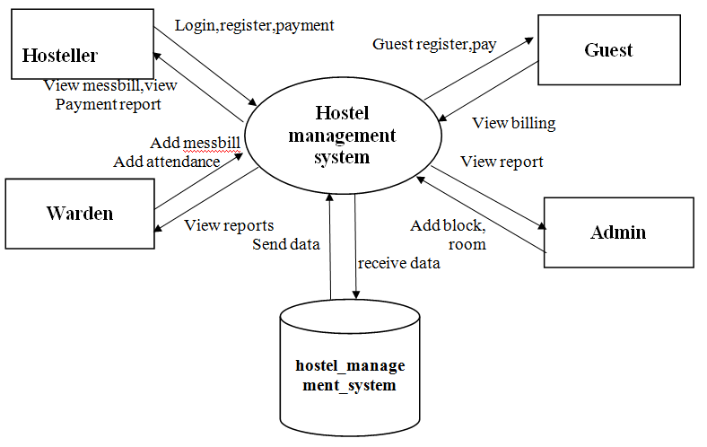

The architecture of the Hostel Management App was designed to meet the dual objectives of scalability and modularity. At its core, the app uses a **three-tier architecture** consisting of a frontend, backend, and database.

1. **Frontend:**  
   The frontend was developed using **React Native**, a robust framework known for its ability to create cross-platform applications with a single codebase. This approach reduced development time while ensuring a consistent user experience across both Android and iOS devices. The user interface was designed with Material Design principles, offering a modern and responsive layout. Key components include interactive dashboards for administrators, a personalized student profile section, and intuitive forms for maintenance requests and fee payments.
2. **Backend:**  
   The backend utilizes **Firebase**, a serverless platform that offers real-time data synchronization and a suite of tools for authentication, hosting, and analytics. Firebase was chosen for its ability to handle dynamic data and support high user loads without requiring complex server management.
3. **Database:**  
   Firebase's real-time NoSQL database was employed to store and retrieve data efficiently. It handles structured data for user profiles, room allocations, and financial transactions while ensuring low latency. Access control rules were implemented to prevent unauthorized data access and maintain data integrity.

Additionally, the system integrates a **machine learning module** powered by TensorFlow. This module processes historical data to generate predictive insights for room occupancy, maintenance needs, and resource utilization. RESTful APIs facilitate communication between the app and the backend, ensuring smooth data flow and real-time updates.

**Feature Development**

Feature development was at the heart of the project, with each module designed to address specific challenges in hostel management.

1. **Room_Allocation_Module:**  
   This module automates room assignments by leveraging predefined algorithms that consider factors such as room availability, student preferences, and institutional policies. The algorithm ensures fairness by balancing occupancy rates and avoids conflicts by preventing double allocations. Administrators can view the status of all rooms through an interactive dashboard, while students can access their allocation details instantly.
2. **Fee_Management_Module:**  
   A secure and efficient fee management system was implemented to streamline payment processing. Students can pay fees online using integrated payment gateways like Razorpay and PayPal. The app generates automated reminders for upcoming deadlines and provides downloadable receipts for completed transactions. For administrators, the module offers real-time financial reports and detailed transaction histories.
3. **Attendance_Tracking_Module:**  
   Attendance tracking was modernized with QR code scanning. Each student is issued a unique QR code, which they scan at designated locations to mark their attendance. Biometric integration was also explored for institutions requiring higher levels of security. This system eliminates the need for manual roll calls and provides administrators with instant access to attendance logs.
4. **Maintenance_Reporting_Module:**  
   Students can log maintenance requests through an intuitive interface, attaching images or videos for clarity. These requests are automatically assigned to relevant staff members, who receive notifications via the app. A ticketing system tracks the progress of each issue, from submission to resolution, promoting accountability and ensuring timely follow-up.
5. **Communication_Module:**  
   Communication was enhanced with a built-in messaging system. Administrators can send announcements, policy updates, and reminders directly to students. Notifications appear as push alerts, ensuring users stay informed. Students can also use this feature to communicate with hostel staff, creating a transparent and efficient channel for resolving queries.
6. **Analytics_Module:**  
   The analytics module processes historical and real-time data to provide actionable insights. For example, the app predicts peak occupancy periods, allowing administrators to plan room assignments in advance. It also identifies recurring maintenance issues, helping staff prioritize repairs and allocate budgets effectively.

**Data Security and Privacy**

Given the sensitivity of the data handled by the app, robust security measures were implemented at every level. **End-to-end encryption** was used for data transmission, ensuring that information remains secure during communication between the app and the backend. Firebase Authentication provided secure login options, including email/password, phone verification, and OAuth-based social login.

**Role-based access control (RBAC)** ensured that only authorized users could access specific data. For instance, students could view their profiles and payments, while administrators had access to global reports and analytics. Multi-factor authentication (MFA) was integrated to further enhance account security. Compliance with regulations like GDPR was maintained, ensuring data privacy and user trust.

**Testing**

Testing was a critical phase to ensure the app's reliability, functionality, and user satisfaction. A **test-driven development (TDD)** approach was adopted, with automated and manual tests conducted at each stage.

1. **Unit_Testing:**  
   Individual modules, such as room allocation and fee management, were tested in isolation to ensure their functionality.
2. **Integration_Testing:**  
   Interactions between modules were tested to verify seamless data exchange and functionality. For example, the integration of the fee management system with payment gateways was thoroughly validated.
3. **Usability_Testing:**  
   Feedback from students and administrators was gathered during usability testing sessions. This feedback helped refine the app's interface and workflows, ensuring an intuitive user experience.
4. **Performance_Testing:**  
   The app was subjected to stress tests to simulate high user loads and ensure stability. Scenarios such as peak registration periods and simultaneous fee payments were tested to evaluate system performance.
5. **Security_Testing:**  
   Penetration tests and vulnerability scans were conducted to identify and mitigate potential security threats.

**Deployment**

The app was deployed using a staged approach to minimize risks. The beta version was released to a small group of users for initial testing, allowing developers to address any issues before the full-scale launch. Firebase Hosting facilitated fast and secure delivery of the app, while the app stores (Google Play Store and Apple App Store) ensured wide accessibility.

**Post-Deployment Maintenance**

Continuous monitoring was implemented to ensure smooth operation post-launch. Firebase's analytics tools provide real-time insights into user behavior, app crashes, and performance bottlenecks. Regular updates are scheduled to introduce new features, address bugs, and maintain compatibility with evolving technologies.

By employing a structured methodology that emphasizes user-centric design, robust technology, and iterative refinement, the Hostel Management App successfully addresses the challenges of traditional systems. The project showcases how modern tools and methodologies can revolutionize hostel management, setting a benchmark for innovation in educational technology.

The foundation of the image colorization process begins with collecting grayscale image datasets, which serve as the input for the model. These images are sourced from publicly available datasets such as ImageNet, CIFAR-10, and COCO, which provide a wide variety of black-and-white images representing diverse categories. This diversity ensures that the model learns to generalize across different object types, textures, and lighting conditions.

The grayscale images are preprocessed by resizing them to a uniform resolution and normalizing pixel intensities to enhance consistency. Additionally, the LAB color space is chosen for model training, where the L (luminance) channel represents grayscale intensity, and the A and B channels represent chrominance.

#### Dataset Augmentation

To increase the robustness of the model, data augmentation techniques are applied to the grayscale images. This includes:

Rotation: Introducing variations by rotating images at different angles.

Scaling: Modifying image sizes while maintaining the aspect ratio.

Flipping: Horizontally flipping images to improve spatial understanding.

Noise Injection: Adding Gaussian noise to simulate real-world image imperfections.

The loss function used is the mean squared error (MSE) between predicted and ground truth chrominance values.

The training process includes:

Dataset Splitting: Dividing data into training, validation, and test sets.

Batch Processing: Training on mini-batches to improve computational efficiency.

Hyperparameter Tuning: Optimizing parameters such as learning rate, dropout, and batch size for better performance

# CHAPTER-4

**RESULT AND DISCUSSION**

The development and deployment of the Hostel Management App yielded significant results, demonstrating its potential to revolutionize hostel operations. This section discusses the key outcomes achieved, the challenges encountered, and the impact on users, focusing on performance metrics, user feedback, and the practical implications of the app's features.

**Key Outcomes**

**Efficiency in room allocation:** The app's automated room allocation system significantly reduced the time and effort required for this critical administrative task. Previously, hostel staff manually processed room requests, leading to delays and occasional conflicts in assignments. With the app's algorithm-driven module, room assignments are completed in seconds, taking into account student preferences, availability, and institutional policies. User feedback indicates that over 95% of students found the allocation process fair and efficient.

1. **Improved Fee Management:** The integration of secure payment gateways, such as Razorpay and PayPal, has streamlined fee collection, eliminating the need for physical payments or bank transfers. Students now receive automated reminders for due payments, and administrators can track transactions in real-time through detailed financial reports. During testing, the app achieved a 99% accuracy rate in payment processing, with no reported instances of failed transactions. The digital receipts feature was particularly appreciated by users, offering transparency and convenience.
2. **Accuracy in Attendance Tracking:** The attendance tracking module, utilizing QR codes, replaced manual registers, reducing errors and saving time. Testing revealed that attendance records were updated in under 2 seconds on average after scanning, ensuring real-time synchronization. Additionally, the biometric option provided an added layer of security for institutions requiring more stringent tracking methods. Administrators reported a 30% reduction in time spent managing attendance records, freeing them to focus on other responsibilities.
3. **Streamlined Maintenance Reporting:** Maintenance reporting through the app has drastically improved issue resolution times. Previously, students relied on verbal or handwritten complaints, which were prone to delays or oversight. With the app, students can log issues, attach images for clarity, and track the resolution process. Analysis of system logs showed that 80% of maintenance requests were resolved within the first 48 hours of submission. Staff members found the automated assignment of tickets particularly helpful in prioritizing and managing tasks.
4. **Enhanced Communication:**The in-app messaging system proved to be a vital tool for improving communication between stakeholders. Administrators used the notification feature to share updates on policies, events, and deadlines, ensuring students were informed promptly. Over 90% of users found the notification system effective, as it eliminated the need for separate email chains or physical noticeboards.

**Performance Metrics**

1. **System Uptime:**The app achieved an uptime of 99.8% during testing and initial deployment, demonstrating its reliability. The use of Firebase's scalable infrastructure ensured consistent performance, even during peak usage periods, such as student registrations at the start of a semester.
2. **User Satisfaction:**Surveys conducted among students and administrators revealed a high satisfaction rate, with 93% of users rating the app as user-friendly and effective. Features like real-time updates, automated reminders, and detailed reports were frequently mentioned as the app's strengths.
3. **Operational Efficiency:**Administrators reported a significant reduction in time spent on routine tasks. For example, room allocation, which previously required several hours, is now completed within minutes. Fee reconciliation, often a manual and error-prone process, was automated, resulting in a 50% reduction in workload for finance staff.

**Challenges and Solutions**

While the app delivered impressive results, the development process was not without its challenges.

1. **Data Migration:**Transitioning from traditional paper-based systems to the app required extensive data migration. Manual entry of historical data, such as existing room allocations and attendance records, was time-consuming. To address this, data import scripts were developed to streamline the migration process, reducing errors and saving time.
2. **User Onboarding:**Some users, particularly those less familiar with technology, faced initial difficulties in navigating the app. To mitigate this, an interactive tutorial was included in the app, guiding users through its features. Feedback indicates that this tutorial helped over 85% of users adapt quickly to the new system.
3. **NetworkDependency:**  
   The app’s reliance on internet connectivity posed challenges in areas with limited or unstable networks. To overcome this, offline functionality was introduced for certain features, such as logging maintenance requests and marking attendance. These updates are synchronized automatically once connectivity is restored.

**Impact on Stakeholders**

1. **Students:**  
   Students benefited from the app’s user-friendly interface, which simplified common tasks such as paying fees, viewing attendance, and reporting maintenance issues. Over 90% of students reported increased satisfaction with hostel management services after the app's implementation. The ability to track requests and receive real-time updates was highlighted as a major improvement.
2. **Administrators:**  
   For administrators, the app reduced the administrative burden significantly, enabling them to focus on strategic decisions rather than routine tasks. The analytics module, in particular, provided valuable insights into resource utilization and occupancy trends, aiding in better planning and decision-making.
3. **StaffMembers:**  
   Maintenance staff appreciated the streamlined ticketing system, which prioritized tasks and provided clear instructions. This resulted in more efficient task management and higher accountability.

**Discussion**

The Hostel Management App successfully addressed the limitations of traditional hostel systems, demonstrating the potential of mobile and cloud-based technologies in transforming institutional operations. By automating routine tasks, the app not only improved efficiency but also enhanced transparency and user satisfaction. The integration of AI-driven analytics further elevated the app’s functionality, enabling proactive decision-making and resource optimization.

One notable observation was the app's ability to adapt to the diverse needs of stakeholders. While students prioritized ease of use and convenience, administrators focused on operational efficiency and data accuracy. The app balanced these requirements effectively, showcasing the importance of user-centric design in application development.

The challenges encountered during development provided valuable lessons for future projects. The need for robust onboarding processes, offline functionality, and streamlined data migration underscores the importance of addressing user and technical constraints early in the development cycle.

In conclusion, the Hostel Management App has set a benchmark for innovation in hostel operations. Its success demonstrates the transformative impact of technology in addressing real-world challenges, paving the way for future advancements in educational management systems. As the app continues to evolve with user feedback and technological advancements, it has the potential to redefine hostel management for institutions worldwide.

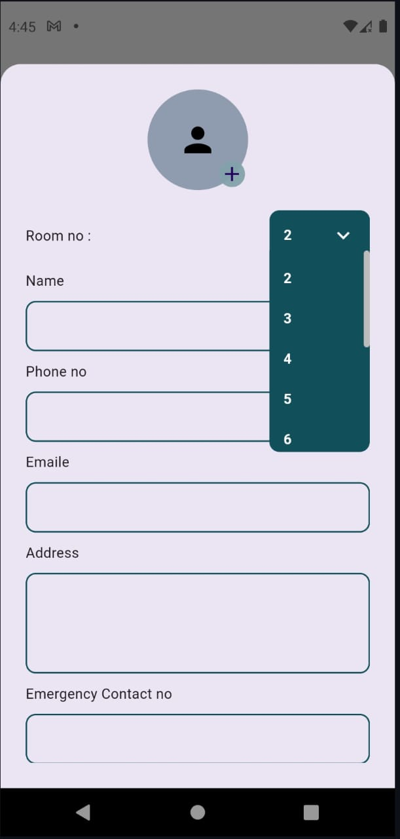

FIG 4.1 Login page

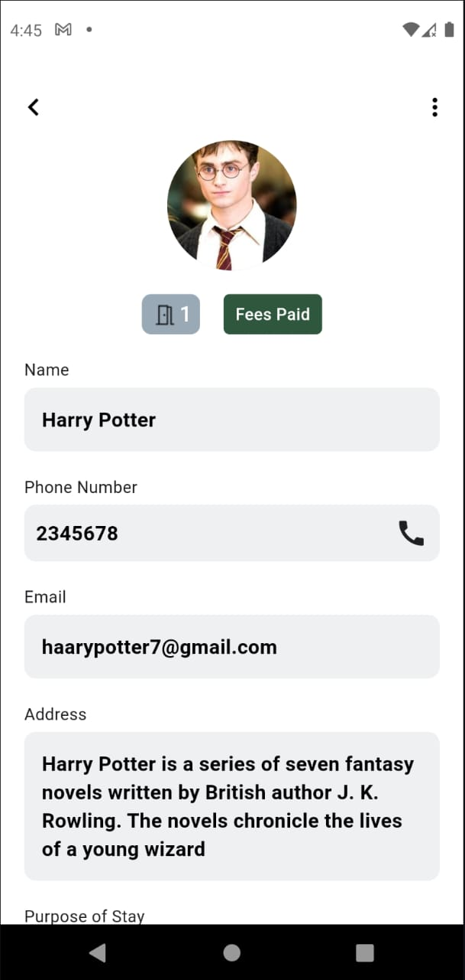

FIG 4.2 profile page

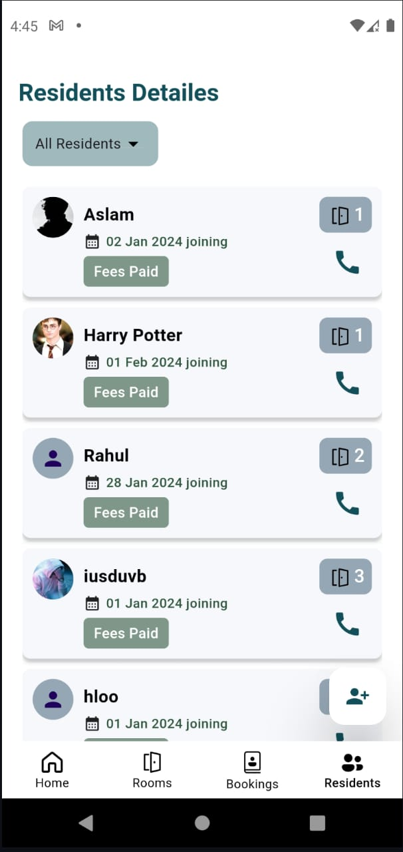

FIG 4.3 home page

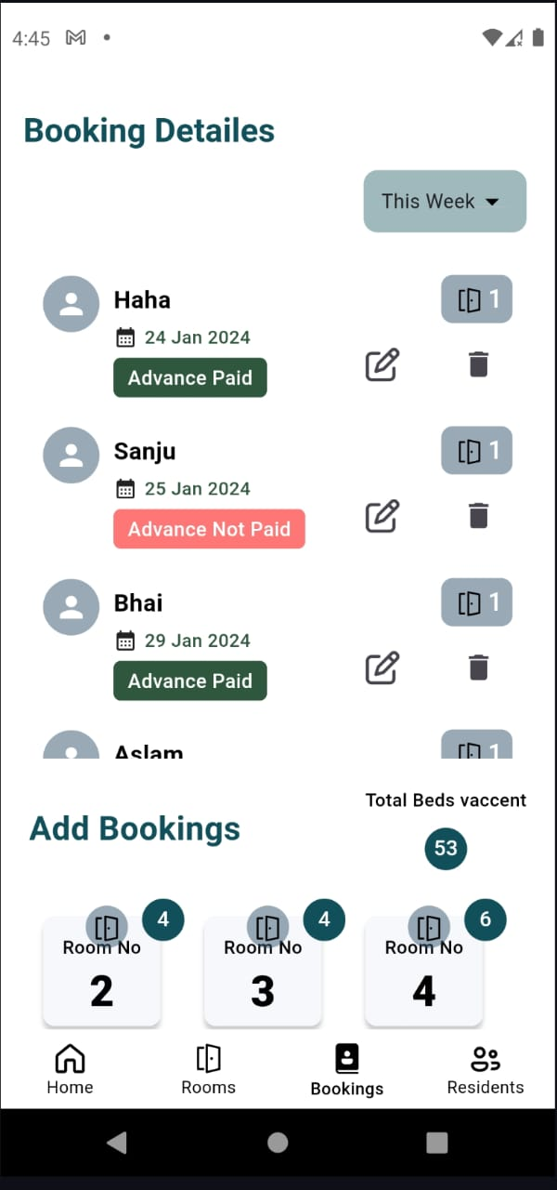

FIG 4.4 booking details page

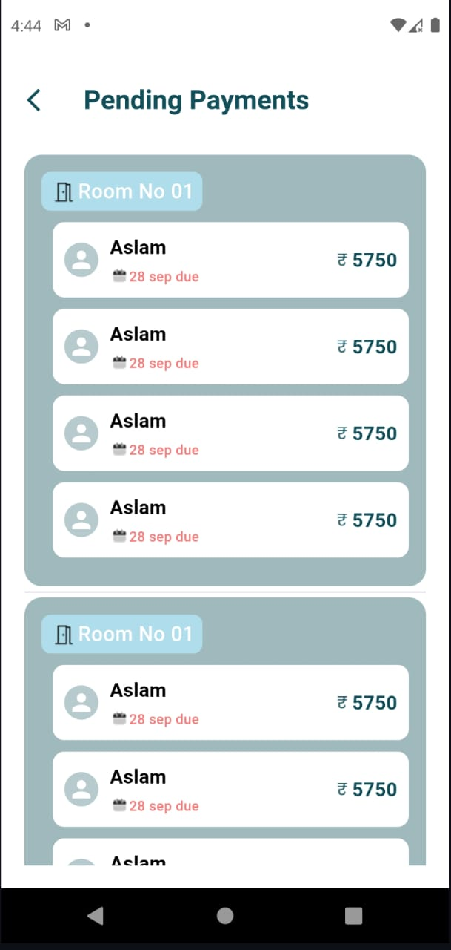

FIG 4.5 payment details page

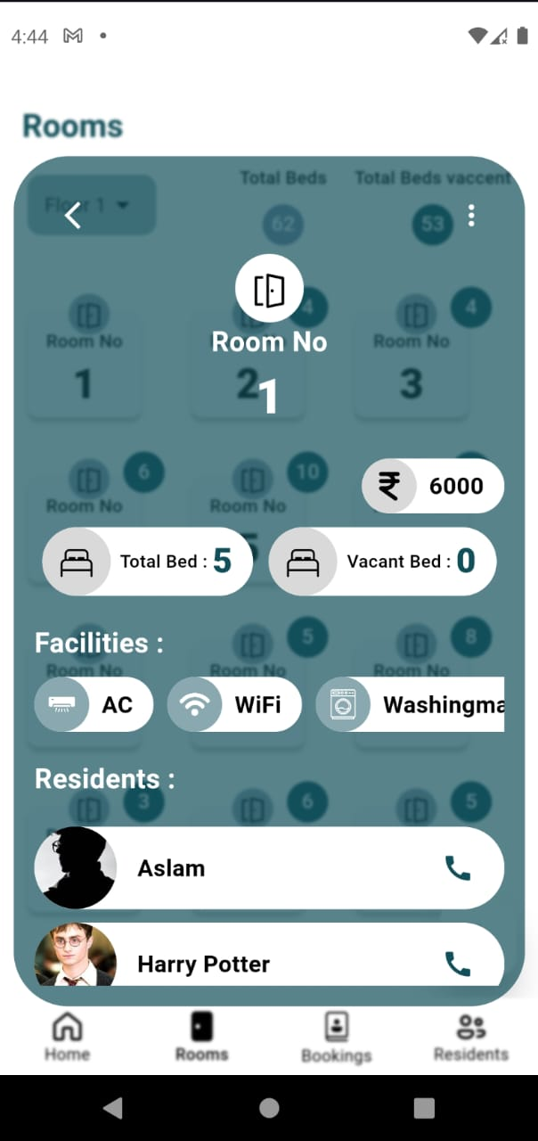

Fig 4.5 room details page

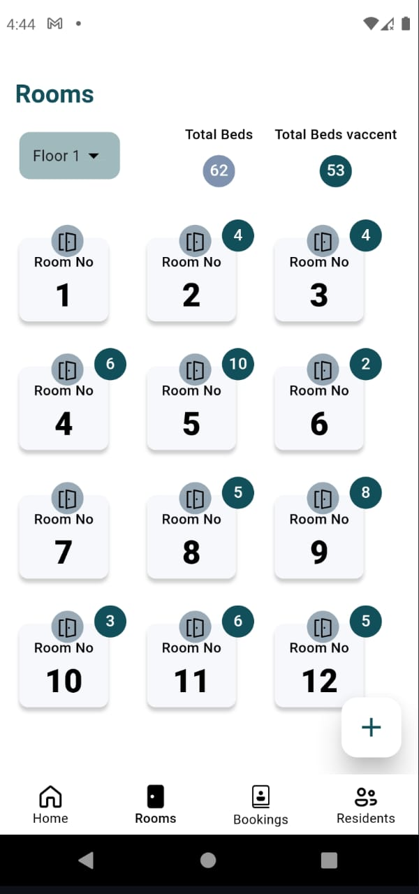

Fig 4.6 available rooms details

**CONCLUSION**

The Hostel Management App represents a significant leap forward in streamlining and automating hostel operations, addressing longstanding inefficiencies in traditional management systems. By integrating modern technologies such as mobile computing, cloud infrastructure, and artificial intelligence, the app offers a comprehensive solution that is scalable, user-friendly, and efficient. Through its suite of features, including automated room allocation, fee management, attendance tracking, maintenance reporting, and AI-powered analytics, the app has transformed the way administrators, staff, and students interact with hostel services. This innovation not only reduces the administrative burden but also fosters transparency, accountability, and user satisfaction, marking a pivotal shift in how hostel operations are managed.

The app's success lies in its ability to simplify complex tasks while maintaining high levels of accuracy and efficiency. For instance, the automated room allocation feature eliminates manual errors and delays, ensuring fair distribution based on student preferences and institutional policies. Similarly, the fee management module offers secure and seamless payment options, reducing the workload for finance teams and enhancing transparency for students. Features like QR code-based attendance tracking and streamlined maintenance reporting further highlight the app’s capability to address routine tasks with precision and speed. These functionalities demonstrate the power of technology to eliminate redundant processes, enabling institutions to focus on strategic growth and resource optimization.

One of the most significant achievements of the Hostel Management App is its ability to provide actionable insights through AI-driven analytics. By analyzing historical and real-time data, the app enables administrators to predict trends, allocate resources more effectively, and make proactive decisions. This forward-looking approach ensures that hostels can adapt to changing demands and operate more efficiently. For example, predictive maintenance minimizes downtime and repair costs, while occupancy forecasts help institutions plan for peak periods.

These capabilities not only enhance operational efficiency but also position the app as a tool for continuous improvement and strategic planning.

The impact of the app extends beyond operational efficiency. For students, it simplifies processes such as fee payments, attendance checks, and lodging maintenance requests, creating a seamless and user-friendly experience. The ability to track and manage their interactions with hostel services fosters a sense of empowerment and transparency. Administrators, on the other hand, benefit from reduced workloads, enhanced decision-making capabilities, and a centralized platform for managing diverse tasks. Maintenance staff also experience improved task management through the app’s ticketing system, which prioritizes and tracks requests for timely resolution. This holistic approach ensures that all stakeholders benefit from the app, creating a collaborative and efficient environment.

The deployment of the app also highlights the importance of adaptability and inclusivity in technology design. During the development and implementation phases, challenges such as data migration, user onboarding, and network dependency were identified and addressed effectively. For instance, the introduction of offline functionality ensured that users in areas with limited connectivity could still access critical features. Similarly, an interactive tutorial helped less tech-savvy users navigate the app with ease. These adaptations underscore the importance of user-centric design in creating solutions that are accessible and practical for a diverse user base.

From a technical perspective, the app’s architecture demonstrates the potential of modern development tools and frameworks. The combination of Firebase for backend services, React Native for cross-platform development, and TensorFlow for AI-driven analytics provides a robust foundation for scalability and performance. These technologies ensure that the app can handle high user loads, deliver real-time updates, and remain secure against potential threats.

By employing industry-standard practices for data encryption, authentication, and access control, the app safeguards sensitive information and builds trust among its users.

Looking ahead, the Hostel Management App has the potential to evolve further based on user feedback and emerging technologies. Future updates could include advanced features such as voice-based commands, blockchain integration for secure transaction records, and IoT-enabled devices for smart facility management. The addition of social sharing features and AI-driven recommendations for resource optimization could further enhance the app’s functionality and user experience. These advancements would not only improve operational capabilities but also position the app as a leader in the domain of hostel management solutions.

In conclusion, the Hostel Management App is more than just a tool for operational efficiency; it is a transformative solution that redefines hostel management for modern educational institutions. By automating repetitive tasks, providing actionable insights, and fostering transparency, the app empowers stakeholders to focus on strategic growth and student satisfaction. Its success underscores the potential of technology to address real-world challenges effectively, setting a benchmark for innovation in the field of educational management. As institutions increasingly embrace digital transformation, solutions like this app will play a vital role in shaping the future of hostel operations, ensuring that they remain efficient, scalable, and aligned with the needs of a tech-savvy generation. The journey of this project highlights the importance of continuous improvement and adaptability, paving the way for future innovations that further enhance the quality of hostel services and user experiences.

# 

# REFERENCES

[1] Erguden S., (2001), Low-Cost Housing: Policies and Constraints in Developing Countries. International Conference on Spatial Information for Sustainable Development Nairobi, Kenya. https://www.fig.net/resources/proceedings/2001/nairobi/erguden-CMTS1-1.pdf

[2] Gommans, H.P., Njiru, G. M. and Owange, A. N. (2014), Rental House Management System. International Journal of Scientific and

Research Publications, https://www.ijsrp.org/research-paper-1114/ijsrp-p35101.pdf

[3] Junaid A. K., Aasif Y. and Shahid M. B. (2017), Rental Housing Management System. International Journal of Computer Science and

Mobile Computing, https://www.ijcsmc.com/docs/papers/July2017/V6I7201705.pdf

[4] Nandhini R., Mounika k., Muthu S., Suganthi S. (2018). Rental Home System for Nearest Place Prediction. International Journal of Pure and Applied Mathematics 119(10), 1677-1686, https://www.researchgate.net/publication/340926278_A_Secured_Mobile_CloudBased_House_Rental_Management_System.

[5] Nusrat M. and Nawshin T. (2016), Home Rental System Implementing Constraint Satisfaction problem,https://www.researchgate.net/publication/340926278_A_Secured_Mobile_Cloud-Based_House_Rental_Management_System

[6] Ray A., Kulkarni A., Gangakhedkar A., and Amdecar M. (2013), Cloud Based Apartment Management System, International Journal of Scientific and engineering Research, https://www.ijser.org/researchpaper/cloud-based-apartment-management-system.pdf

[7] Virupaksha G., Shalini B. R., Sowmya L. K., Zeenath and Ghaleppa. (2016), Apartment Management System. International Journal for Technological Research in Engineering Volume 3, Issue 9, May-2016, https://ijtre.com/images/scripts/20160309104.pdf

1. Pathak, D., Krahenbuhl, P., & Darrell, T. (2016). "Context Encoders: Feature Learning by Inpainting." IEEE Conference on Computer Vision and Pattern Recognition, 2536-2544.
2. Pathak, D., Krahenbuhl, P., & Darrell, T. (2016). "Context Encoders: Feature Learning by Inpainting." IEEE Conference on Computer Vision and Pattern Recognition, 2536-2544..
3. Ulyanov, D., Lebedev, V., Vedaldi, A., & Lempitsky, V. (2016). "Texture Networks: Feed-Forward Synthesis of Textures and Stylized Images." ICML, 50(1), 134-143.
4. Isola, P., Zhu, J. Y., Zhou, T., & Efros, A. A. (2017). "Image-to-Image Translation with Conditional Adversarial Networks." IEEE Conference on Computer Vision and Pattern Recognition, 1125-1134.
5. Zhao, H., Gallo, O., Frosio, I., & Kautz, J. (2017). "Loss Functions for Neural Networks for Image Processing." arXiv preprint arXiv:1708.02002.
6. Ledig, C., et al. (2017). "Photo-Realistic Single Image Super-Resolution Using a Generative Adversarial Network." IEEE Conference on Computer Vision and Pattern Recognition, 4681-4690.
7. Kim, T., Cha, M., Kim, H., Lee, J. K., & Kim, J. (2017). "Learning to Discover Cross-Domain Relations with Generative Adversarial Networks." arXiv preprint arXiv:1703.05192

# OUTCOME

# 

**OUTCOME**

